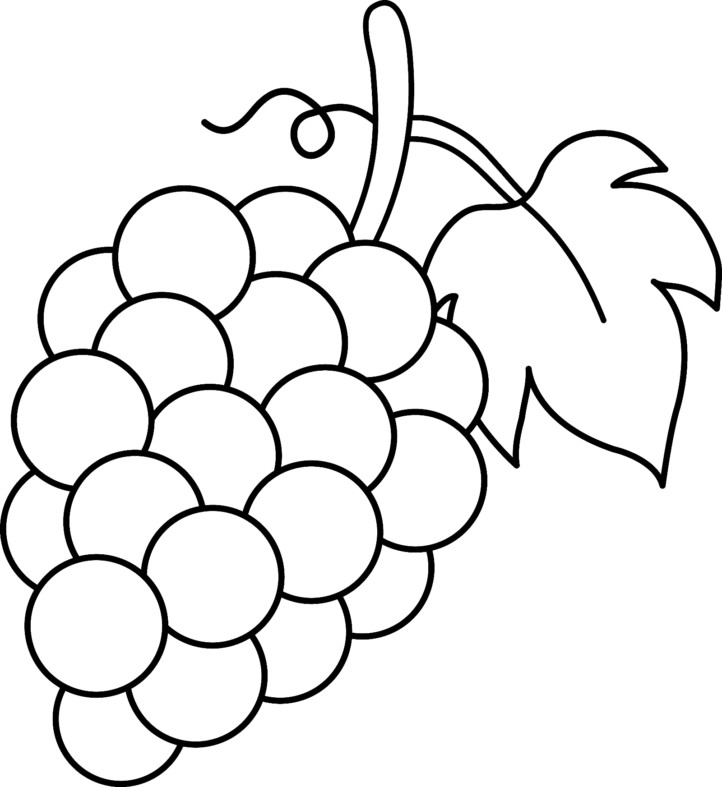

I am the vine, and you are the branches. If you stay joined to me, and I stay joined to you, then you will produce lots of fruit. But you cannot do anything without me.
John 15:5

